--/ FORMAT MUST BE EXACT OTHERWISE THE DROPDOWNS MAY BE CORRUPT!!! \--

Format: Replace the values in QUOTES with your values for each dropdown

"itemType"-"dropdownstyle"["itemName"("Price"),],

\*\* ALL Item Names are separated by commas EX: ,

-EXCEPT for the last Item Name in the list of item Names for EACH item Type

\*\* ALL Item Types are separated by pluses EX: +

-EXCEPT for the last Item Type in the list of Item Types

\*\* IF there is NO PRICE then the DEFAULT is FREE

\*\* Item Names CAN HAVE SPACES

\*\* Dropdown Style can ONLY have ONE OF TWO values (MUST BE LOWERCASE FOR THE DROPDOWN STYLE):

m - a multiple item select

s - a single item select

Dropdown Style: (*The names and prices in this example aren’t entirely accurate, but are to represent the general concept of what the term m or s represent*)

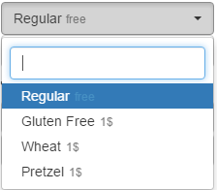 m - multiple: s - single:

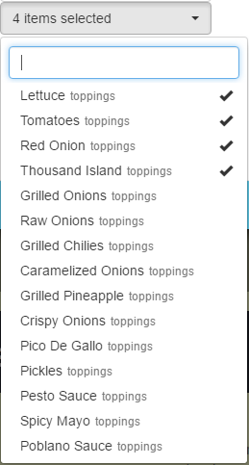

FOR EXAMPLE:

bun-s[Regular(),Gluten Free(1),Wheat(1),Pretzel(1selected)]+

patty-s[Beef(1selected),Turkey(1),Veggie(1),Grass Fed(3)]+

addons-m[Egg(1),Avocado(1),Side Salad(1)]+

cheese-s[Swiss Cheese(1),American Cheese(1)]+

toppings-m[Grilled Onions(),Raw Onions(),Grilled Chilies(),Caramelized Onions(),Grilled Pineapple(),Lettuce(),Tomatoes(),Crispy Onions(),Pico De Gallo(),Pickles(),Pesto Sauce(),Spicy Mayo(),Poblano Sauce()]